20701313 Taek Lim hw1

Webots

Installation
No | Source | location | desc | Actions
1 | Webots | https://cyberbotics.com/ | Download https://github.com/cyberbotics/webots/releases/download/R2025a/webots-R2025a.dmg | Dmg downloaded
2 | mac | Local | Install | Installed dmg

Running
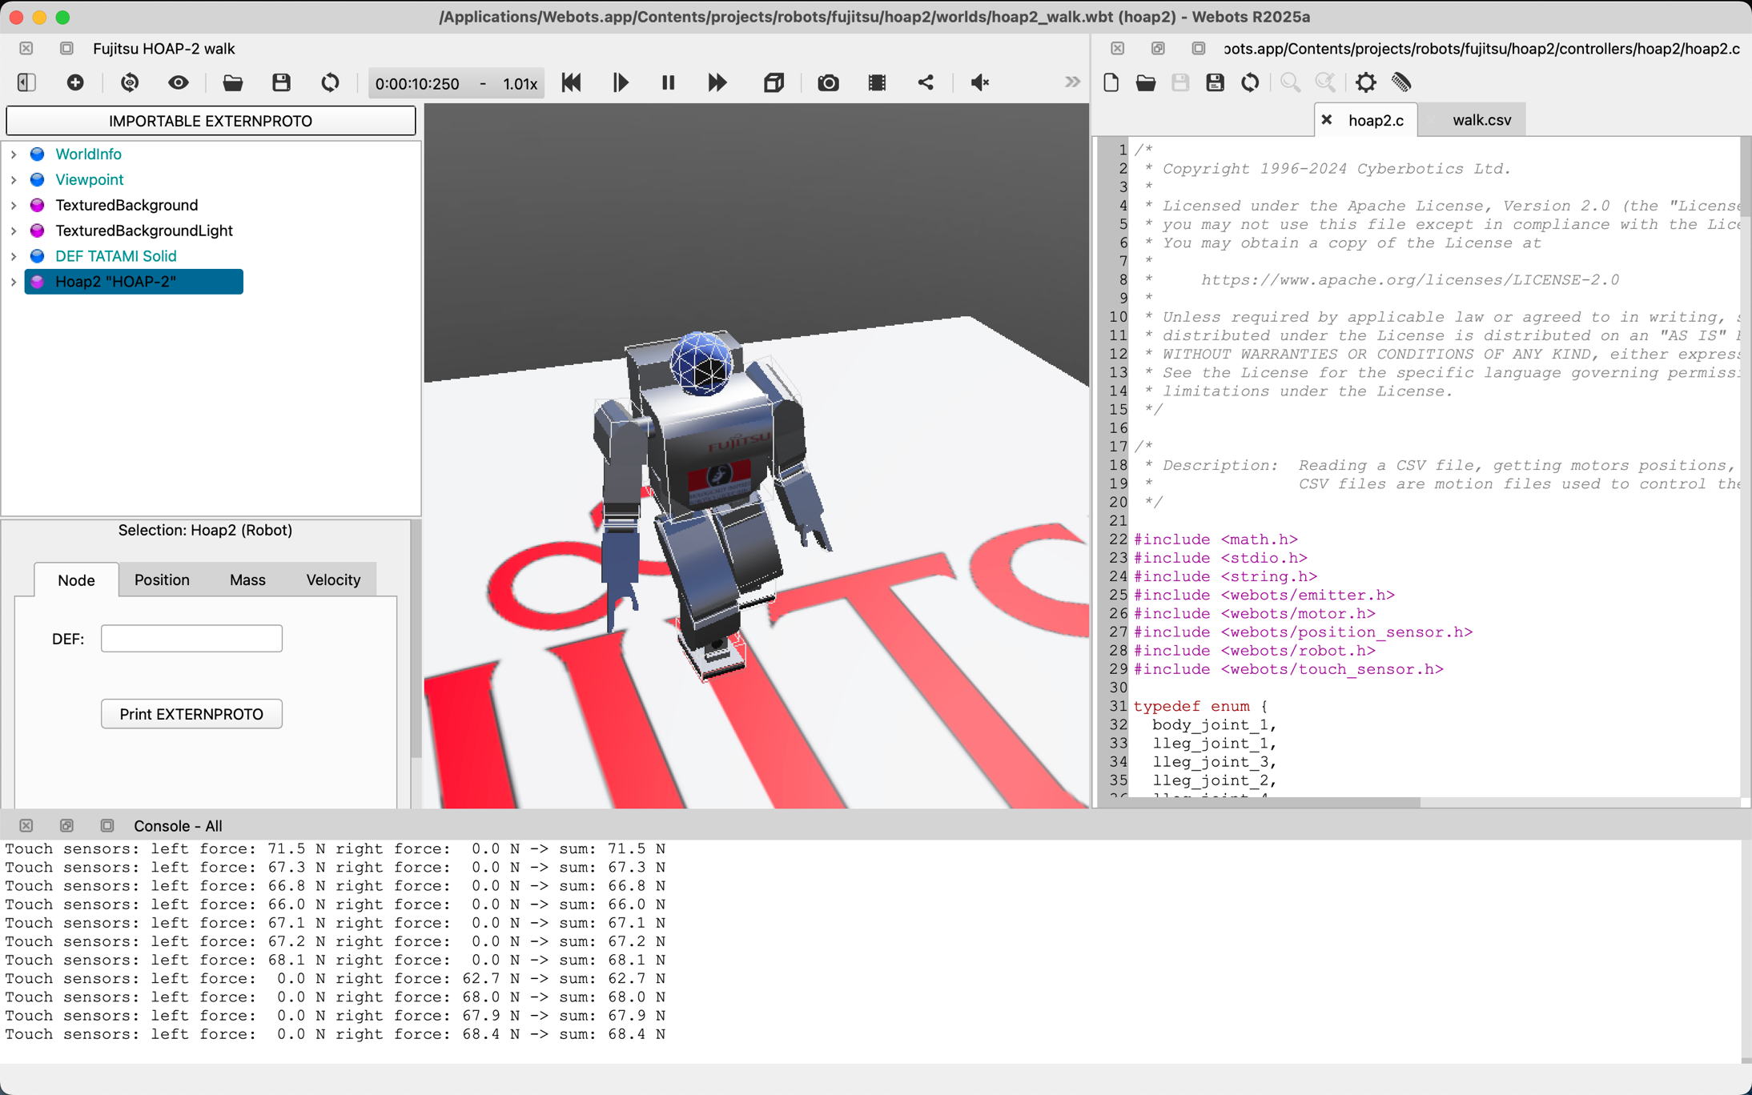

ARGoS 3

Installation
no | source | location | desc | actions | pass
1 | ARGoS3 | https://www.argos-sim.info/core.php | Find a guide | Homebrew Formula for MacOSX  On MacOSX, ARGoS can be installed through Homebrew.  Configuring Homebrew  To get the Homebrew Formula working, you need to add the dedicated tap:  $ brew tap ilpincy/argos3  This operation is necessary only once, to make the first installation of ARGoS possible.  Installing ARGoS  To install ARGoS for the first time, it is enough to write this command:  $ brew install bash-completion qt argos3  This command installs ARGoS along with the recommended dependencies.  Updating ARGoS  To update an installed version of ARGoS to the newest version, first update the formulas:  $ brew update  and then upgrade ARGoS:  $ brew upgrade argos3 | 1
2 | Homebrew | mac | add ARGoS3 tap | brew update  brew tap ilpincy/argos3 | 1
3 | Homebrew | mac | add dependencies | brew install bash-completion qt | 1
4 | Homebrew | mac | Install ARGoS3 | brew install argos3 | 0
5 | Homebrew | mac | Trust tap | brew trust ilpincy/argos3 | 1
6 | Homebrew | mac | Install ARGoS3 | brew install argos3  need < 3.5 but 4.4.3 | 0  cmake version
7 | CMake | mac | cmake version | cmake --version: 4.4.3 | 1
8. brew failed so I gave up with Homebrew
9 | web | https://www.argos-sim.info/core.php | find a guide | ARGoS Source  The ARGoS source is hosted on github: https://github.com/ilpincy/argos3.  To download it, open up a terminal and clone the repository with this command:  $ git clone https://github.com/ilpincy/argos3.git argos3  To compile the source, follow these instructions. | 1
10 | git | https://github.com/ilpincy/argos3 | check repo | Mac OSX  On Mac, you can install all of the necessary requirements using HomeBrew. On the command line, type the following command:  $ brew install pkg-config cmake libpng freeimage lua qt \  docbook asciidoc graphviz doxygen | 1
11 | Homebrew | local | dependencies | brew install pkg-config cmake libpng freeimage lua qt docbook asciidoc graphviz doxygen | 1
12 | mac | local | folder | cd ~  mkdir temp  cd temp | 1
13 | git | local | git clone | git clone https://github.com/ilpincy/argos3.git argos3 | 1
14 | Build | local | build directory | cd argos3  mkdir build_simulator && cd build_simulator | 1
15 | CMake | local | check cmake | cmake ../src -DCMAKE_POLICY_VERSION_MINIMUM=3.5 | 1
16 | Make | local | make compile | make | 1
17 | CMake | local | local prefix configure try | cmake ../src -DCMAKE_POLICY_VERSION_MINIMUM=3.5 -DCMAKE_INSTALL_PREFIX=$HOME/.local | 1
18 | Make | local | install | make install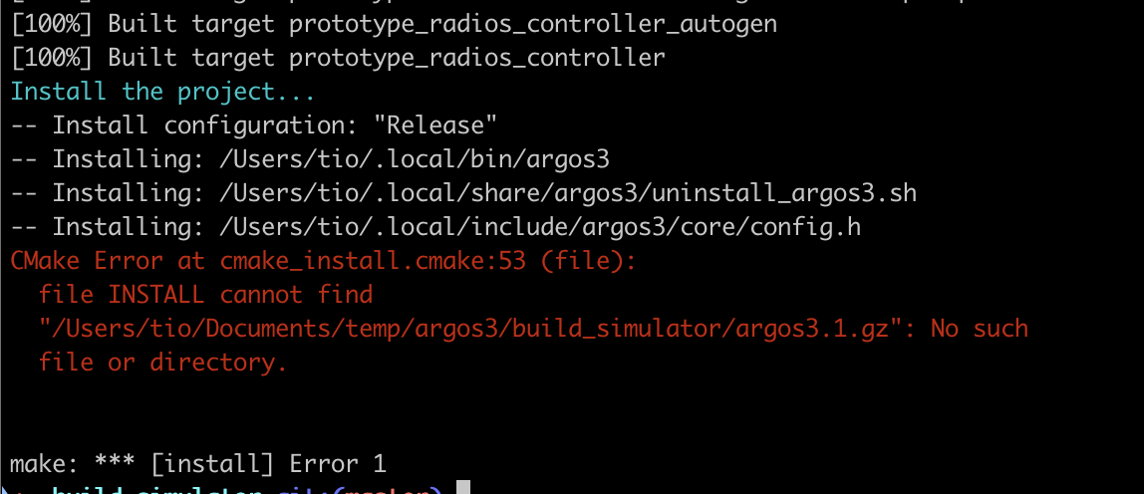 | 0  no argos3.1.gz
19 | CMake | local | install with local path | cmake ../src \  -DCMAKE_POLICY_VERSION_MINIMUM=3.5 \  -DCMAKE_INSTALL_PREFIX=$HOME/.local \  -DCMAKE_PREFIX_PATH=$(brew --prefix qt) | 1
20 | Make | local | make install | make install | 0  no doc build
21 | Make | local | make doc install | make doc | 1
22 | Make | local | make install | make install | 1
23 | zsh | local | add path var | echo 'export PATH="$HOME/.local/bin:$PATH"' >> ~/.zshrc | 1
24 | zsh | local | apply | source ~/.zshrc | 1
25 | git | git clone https://github.com/ilpincy/argos3-examples | clone | cd ~  cd temp  git clone https://github.com/ilpincy/argos3-examples.git | 1
26 | CMake | local | build | cd ~/temp/argos3-examples  mkdir build  cd build  cmake .. -DCMAKE_BUILD_TYPE=Release -DCMAKE_PREFIX_PATH=$HOME/.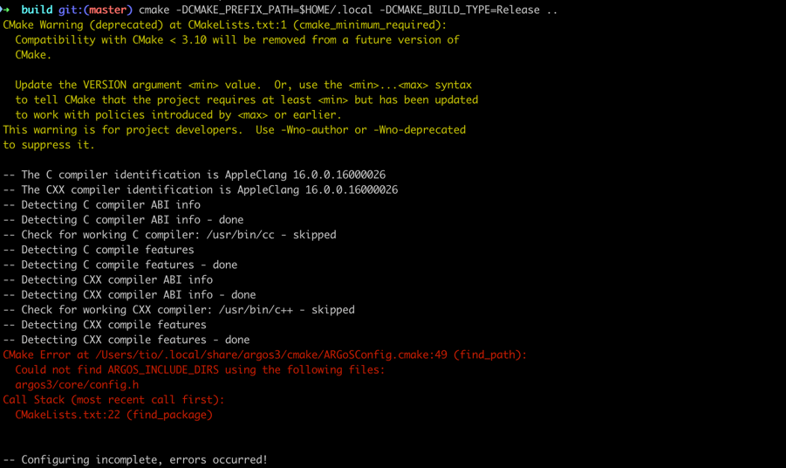local | 0  failed to find core library  Could not find ARGOS_CMAKE_DIR using the following files: FindARGoSQTOpenGL.cmake
27.

I gave up using ~/.local path, but decided to use default path: /usr/local so I deleted all .local related data

bash ~/.local/share/argos3/uninstall_argos3.sh

rm -f ~/.local/bin/argos3
rm -rf ~/.local/include/argos3
rm -rf ~/.local/lib/argos3
rm -f ~/.local/lib/libargos3*
rm -rf ~/.local/share/argos3

source ~/.zshrc

cd ~/temp/argos3
rm -rf ./build-simulator

cd ~/temp/argos-examples
rm -rf ./build

cd ~
rm -rf
28 | mac | local | create build folders | cd ~/temp/argos3  mkdir build-simulator  cd ~/temp/argos3-examples  mkdir build | 1
29 | CMake | local | default path build | cd ~/temp/argos3/ build-simulator  cmake ../src \  -DCMAKE_POLICY_VERSION_MINIMUM=3.5 \  -DCMAKE_BUILD_TYPE=Release \  -DCMAKE_INSTALL_PREFIX=/usr/local \  -DCMAKE_PREFIX_PATH="$(brew --prefix qt)" | 1
30 | Make | local | install doc | make doc | 1
31 | Make | local | install argos | sudo make -j"$(sysctl -n hw.ncpu)" | 1
32 | mac | local | check | which argos3 | 1
check:

/usr/local/
├── bin/
│ └── argos3
├── include/
│ └── argos3/
├── lib/
│ └── argos3/
└── share/
└── argos3/
33 | mac | local | argos3-exmaple | cd ~/temp/argos3-examples | 1
34 | CMake | local | build example | cmake -DCMAKE_BUILD_TYPE=Release .. | 1
35 | Make | local | install example | sudo make -j"$(sysctl -n hw.ncpu)" | 1
36 | mac | local | check exmaple | cd ~/temp/argos3-examples  cd experiments  ls -al  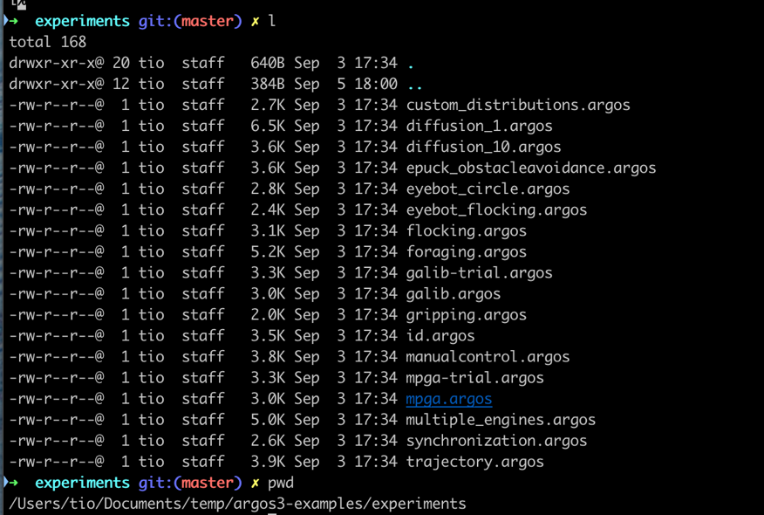 | 1
37 | mac | local | run example | argos3 -c ~/temp/argos3-exmaples/experiments/diffusion_10.argos | 1
38. Installation done and run an example successfully

Running
